******OEWeb

***Administrative User’s Guide***

Contents

OVERVIEW 2

Creating an Open Educational Resource (OER) Course 3

Step 1: Add an Institution (University) to *OEWeb* 3

Step 2: Add Faculty Members and Instructors 6

Step 3: Add Categories 8

Step 4: Add Content 10

Upload a File 10

Add a Lecture 13

Create a Course Shell 14

Step 5: Connect or “Join” the Content Items to the Course 16

ADDITIONAL FUNCTIONALITY:

TESTIMONIALS, CONTACT REQUESTS, BROKEN LINKS, AND PROMOTIONS 20

Testimonials 20

Contact Requests 22

Broken Links 24

Promotions 25

Setting up a promotion 25

Setting up rotating promotions 27

Arbitrary Content 30

Layout Templates 33

FUNCTIONAL REFERENCE 36

Dashboard Functions 36

OCW 36

Categories 36

Persons 37

Degrees 38

Universities 38

Testimonials 38

Contact Requests 39

Promotions 39

Website Header Functions 40

Users 40

Roles 41

Cache 43

# OVERVIEW

Welcome to ***OEWeb***, an open source web-based platform for hosting your institution’s Open Educational Resources (OERs). This guide helps you get started setting up your site and uploading your content, and assumes that you have already configured the appearance of the site with your institution’s logo, color scheme, and other design options. (Instructions for this are provided in a separate document.)

There are five main steps to setting up your content in ***OEWeb***:

1. Enter information about your institution’s *administrative* structure (names of schools, departments, degrees, and other categories).
2. Enter information about your institution’s faculty members and instructors.
3. Enter information about your institution’s *academic* structure (categories of subject areas)
4. Add collections, courses, lectures, and files to the system.
5. Link the above elements together to form collections and courses.

After all five steps have been completed, the newly created and/or uploaded items will be available on your site. To facilitate data entry, each element (course, lecture, etc.) has its own web form for collecting information. The data are then stored in a relational database.

This guide is divided into three parts. The **first part** of this guide shows you how to set up a course on the site using the most commonly used features of the system and the **second part** addresses ancillary features including the ability to feature unsolicited testimonials on the site, post “promotions” on specific pages, and identify broken links. The **third part** features a complete reference for all the ***OEWeb*** functionality.

# Creating an Open Educational Resource (OER) Course

Before you can begin setting up your course, you need to make sure the system contains basic information including relevant school and department names along with the name of the faculty member(s) who authored or collaborated on the course. Once this information is in the system, you can retrieve it each time you set up new content.

## Step 1: Add an Institution (University) to *OEWeb*

First, log into the system using the credentials provided by your system administrator. The dashboard shown in Figure 1 appears. You can enter institutional information through *Universities*, *Persons*, and *Degrees*. Begin with *Universities*. (If your institutional information already exists, you can skip this step.)

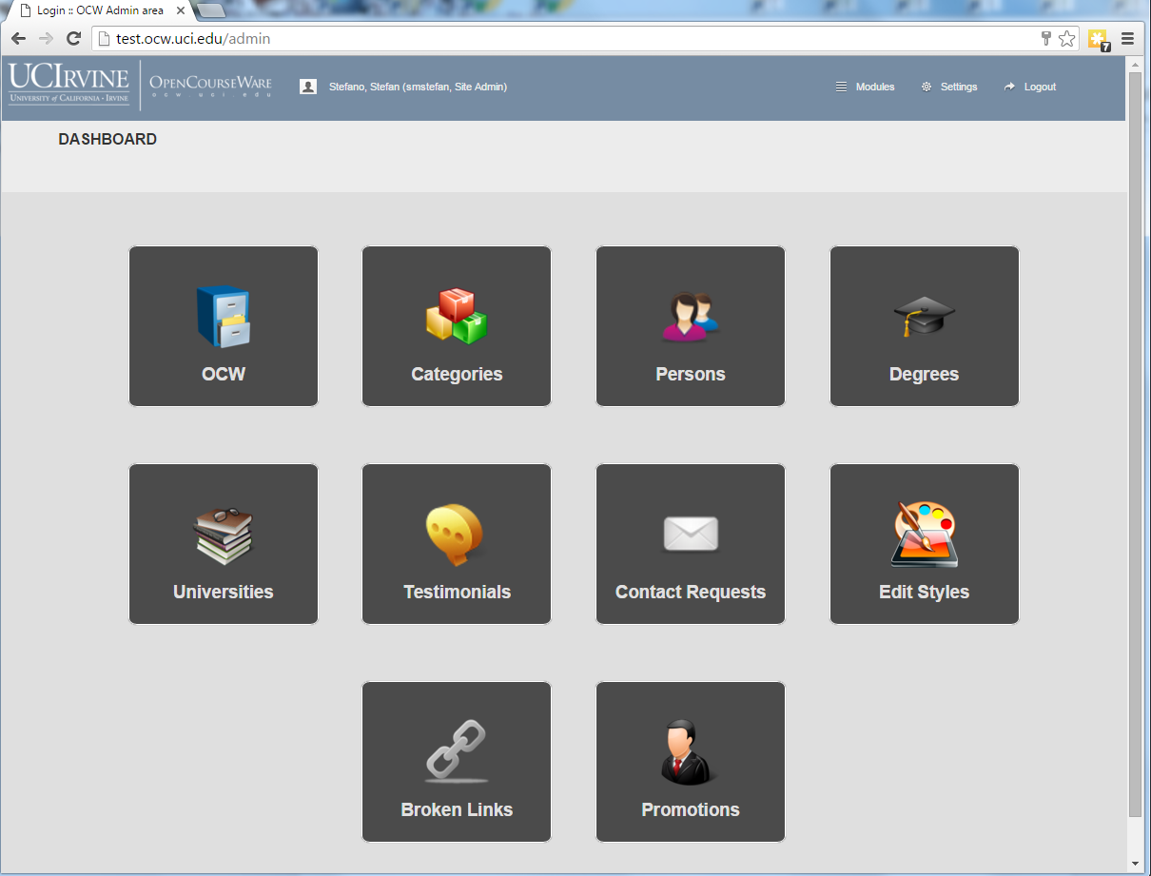

Figure : Dashboard

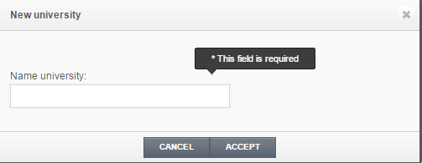Click on *Universities* to open a list of institutions along with schools and departments (Figure 2).

Add an institution (university)

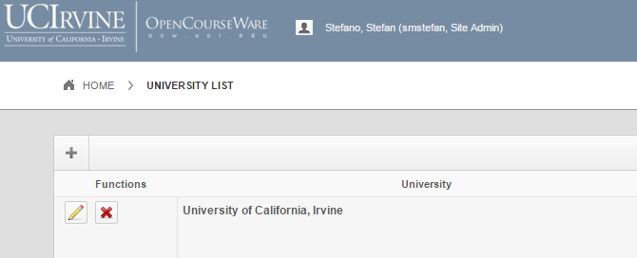

*Figure 2: List of institutions*

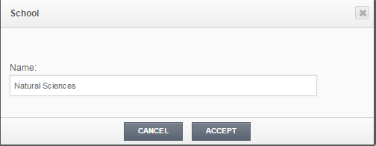Click on the plus sign and enter the name of your institution (“University of Earth” is the example institution.) Click *Accept* and the window in Figure 3 appears. Click on the plus sign to begin entering school and department names. (Some institutions use “colleges” or other names instead of “schools” as their major administrative subdivision.) Enter the name of the first school and click *Accept*.

Edit university name

Add schools

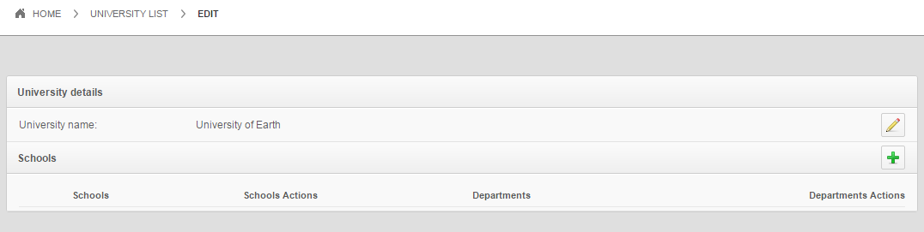

Figure : University administrative organization

At this point, “Natural Sciences” appears as a school and you have the option to edit (modify the name) or delete it. Click on the plus sign (under *School Actions*) in order to enter a department name (“Physics” for this example). Click on *Accept*. Figure 4 summarizes the various activities associated with schools and departments.

Figure : Activities associated with schools and departments

Edit department name

Delete department name

Edit university name

Add schools

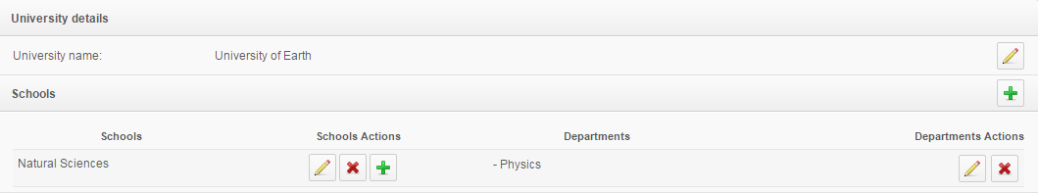

Edit school name

Delete school name

Add departments

The newly added university, school, and department now appear in the system’s *University List* (Figure 5). From this window you can edit the university information or delete it from the system.

Figure : University, school, and department information

Next you need to ensure that your institution’s degrees (Ph.D., M.S., etc.) are in the system so when you enter faculty members, you can designate their degrees. From the dashboard, click on *Degrees* (Figure 6).

Add a degree

Delete a degree

Edit a degree name

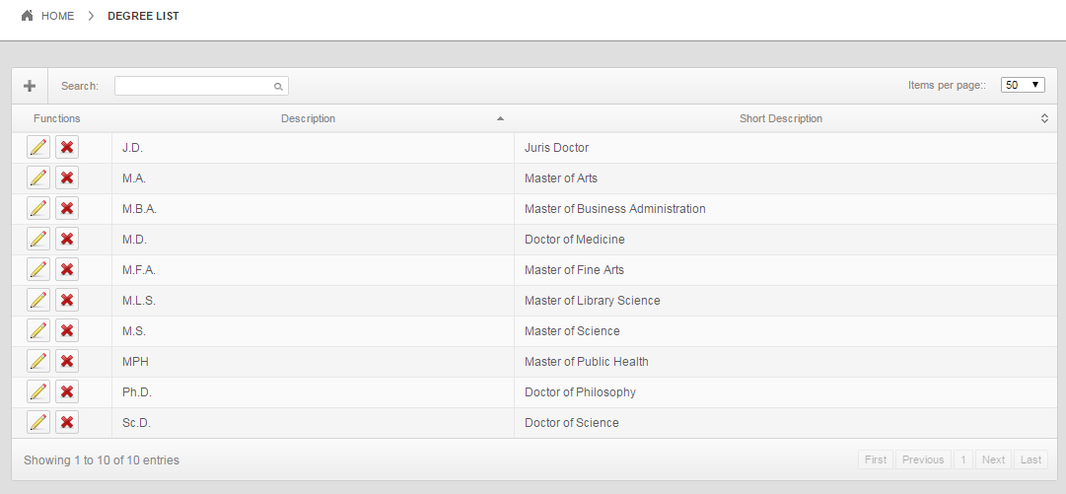

Figure : Degree list

You can add new degrees, edit existing ones, or delete degrees from this page. It functions much like the university, school, and department pages. Remember to click “Save” after adding a new degree or editing existing information.

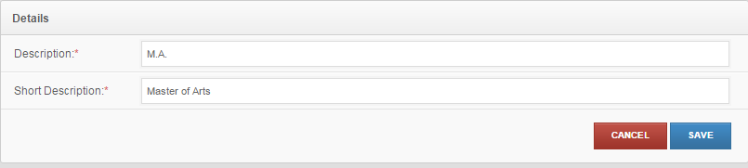

Figure : Degree editing

## Step 2: Add Faculty Members and Instructors

The last piece of administrative information that you need to enter is your course’s instructor or “author.” From the dashboard, click on “Persons,” which opens a list of people who have a role with your institution’s courses (Figure 8).

Add new faculty or instructor name

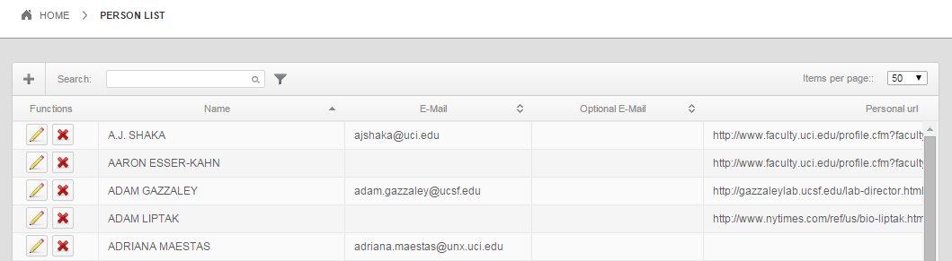

RUDY JOHNSON

TOM ALBERTSON

LETICIA ALVAREZ

JANE JONES

JOHN SMITH

Figure : List of people associated with the courses in your institution

Just as with degrees, you can add new people or edit/edit existing people from this page.

Add a new faculty member by clicking on the plus sign. This opens a form, the top of which is shown in Figure 9. Most of the fields are self-explanatory; those marked with an asterisk are mandatory. Select the person’s degree by clicking on the drop-down menu and making your choice. Note that you must add degrees to the system (*Degrees* on the dashboard) *before* adding new faculty members.

It is very important to click the green plus sign after selecting the degree; this action associates the degree with the person. You can select multiple degrees for one person simply by finding the degree in the drop-down menu and repeatedly clicking the green plus sign (Figure 9). Ensure that the selected degree(s) appear in the lower part of the *Degree* field as shown in the figure.

Click after selecting degree in the dropdown menu

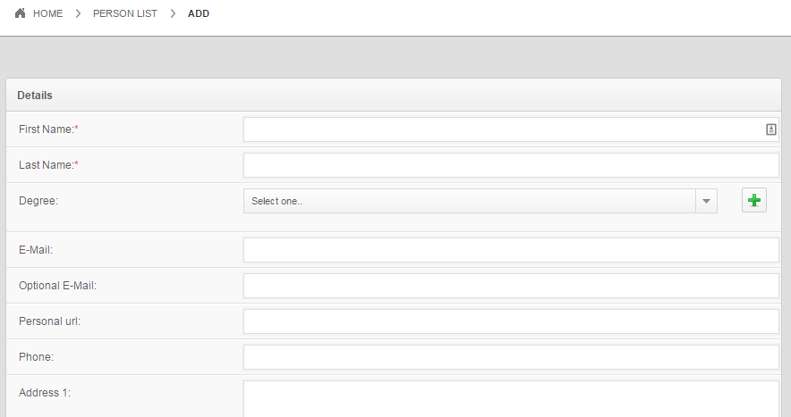

Figure : Upper part of the faculty member data entry form

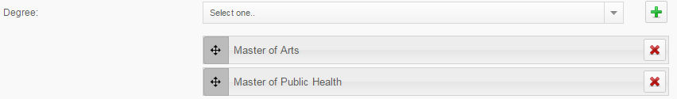

Figure : Example of a person who has two degrees

Toward the bottom of the form is a place to add the faculty member’s department. Click on the green plus sign and a pop-up window appears allowing you to specify the institution, school, department, and professional title as shown in Figure 11. Click *Accept.*

The faculty member’s affiliation and degree appears as shown in Figure 12. Note that one person can be affiliated with multiple universities, schools, and departments. You can continue adding these elements by clicking on the green plus sign. It is desirable to fill in the rest of the form but not absolutely necessary. When finished, click “Save” at the bottom of the form before exiting. The system will return you to the “person list.” Click on “Home” to return to the dashboard.

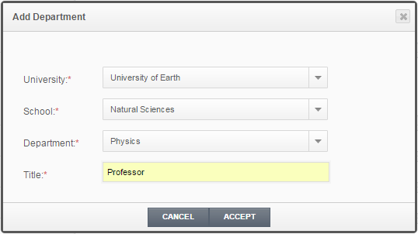

Figure : Pop-up window for specifying a faculty member's affiliations and title

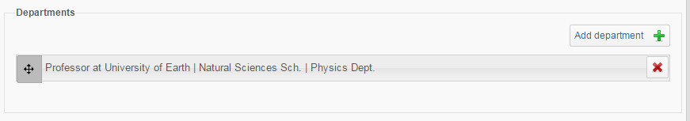

Figure : Faculty member's information

## Step 3: Add Categories

The next piece of information that you need to add to ***OEWeb*** represents the academic structure of the institution – departments, areas of concentration, and subjects – and is called *Categories*. At first, it may appear that *Categories* and the schools/departments in *Universities* are the same, however they are different and the information is used in different places within ***OEWeb***.

Click on *Categories* and the window in Figure 13 appears. The figure truncates the list just below *Neurology and Behavior*, but you can see how *Arts* and *Biological Sciences* appear as high-level categories while the other items appear as lower-level categories. The main difference between the items under *Universities* and those under *Categories* is that *Universities* comprise *administrative* subdivisions consisting of schools and departments while *Categories* comprise *academic* subdivisions that do not necessarily correspond to department names. For example, there may be one Physics Department but several areas of concentration such as Solid State Physics and High Energy Physics within that department. It is possible to list those two areas within physics as distinct categories.

This page lets you drag-and-move the categories so you can sequence them in a desired order. By dragging a category to the left or right, you can make it a higher-level or lower-level category, as desired.

Add a new category

Save changes to the category list

Edit category name

Delete category name

“Drag and move” category to re-sequence or make one category a sub-category of another category

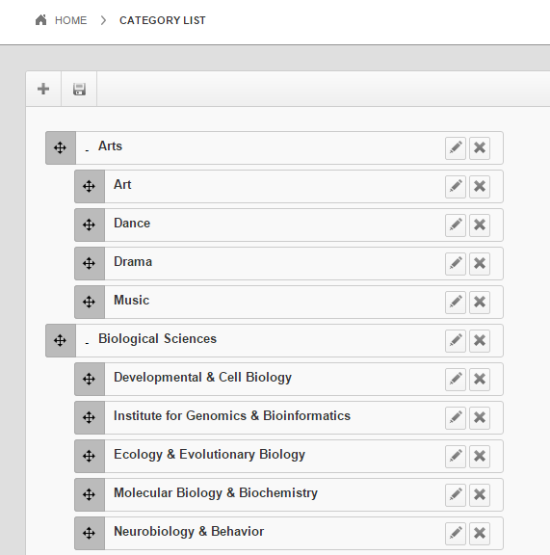

Figure : Category list

“Art” is a sub-category of “Arts”

Website visitors can search for content on specific topics using these categories, which appear on the site’s search page in the same sequence and with the same relationships as in this list. Note that the system does not automatically alphabetize the list – users must do it themselves!

Two important notes: (1) Before deleting a category, you must delete all subcategories. (2) After you have optimally arranged the categories, remember to click the *save* icon at the upper right.

## Step 4: Add Content

At this point you are ready to begin focusing on the course itself. First, you need to upload and arrange the content, which consists of actual files as well as links to videos. The types of content are:

* Collection – may contain courses, individual files, or lectures
* Course – may contain files and lectures
* File – individual items such as PDF documents, Word documents, Excel spreadsheets, etc.
* Lecture – descriptive information plus a link to a video

Collections and courses are “containers” that help organize course content objects in a logical manner and make it easy for users to find contents on specific subjects. Each of these four elements have data associated with them including a title, a description, various tags for search purposes, the author’s name, the Creative Commons licensing option, and other information. Files and lectures can be uploaded into the system in any order.

### Upload a File

Start adding content by adding a file.

From the dashboard, click on *OCW* to open a list of existing course elements (Figure 14). 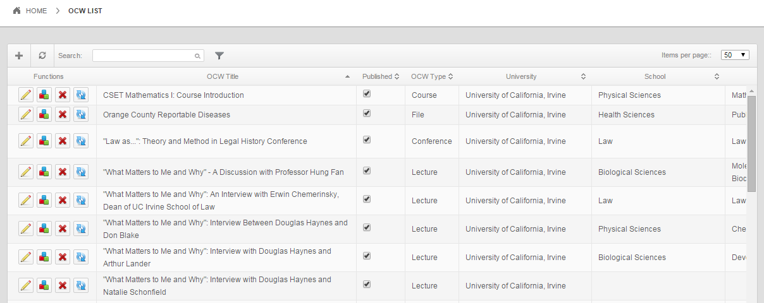

Add new content

Figure : List of course elements (learning objects)

All types of learning objects will appear in this list. You can search for existing objects using the search capability or click the plus sign to add a new object. Clicking the plus sign brings up the content form shown in Figure 15 (with information already entered for an example file). Note that most of the information can be selected from dropdown menus but that the title and description are text fields requiring manual entry. (You can see the importance of entering the categories before trying to add content to the system!) Remember to click the green plus sign after selecting a category in order to associtate that category with the content item. Don’t worry about “promotions placement” right now. Click *Next*.

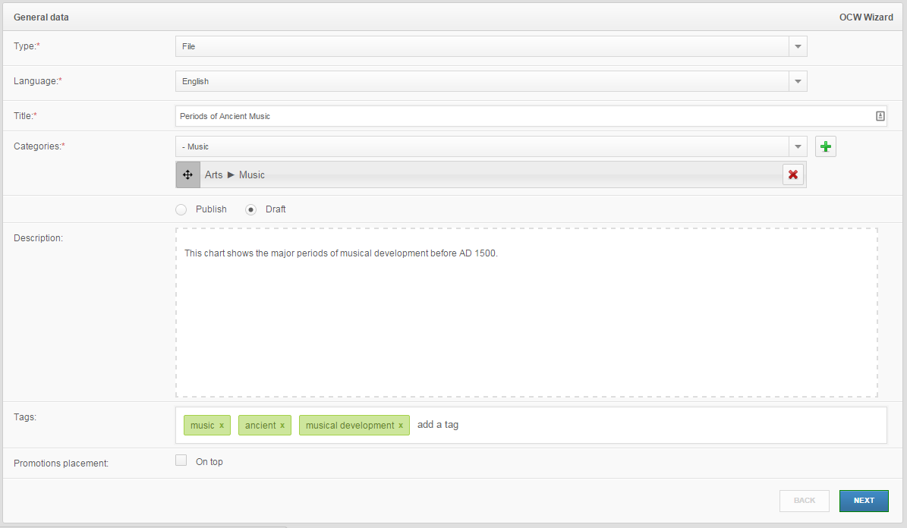

Figure : General data form for a content item

Drag the file from your computer desktop to the green rectangle in order to upload it into the system. After uploading, its URL appears automatically in the File Url text box. After that you must enter information about the file’s author and university afiliation. Click Next (Figure 16).

Drag file from desktop

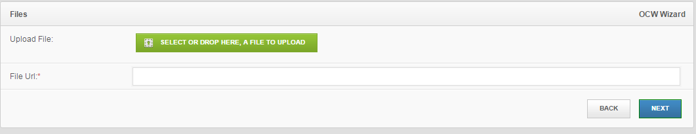

Figure : Drag-and-drop window for selecting file



The author must already exist in the system – select him/her from the dropdown menu. Be sure to click the green plus sign to associate him/her with the file. (You may have noticed that the green plus sign appears wherever multiple items may be chosen.) You also need to choose a school and department (which, as you recall, are not tied to the categories). Note that while the system does allow you to upload an image for the file, the image is not displayed anywhere so it is safe to ignore it. Finally, use the Open License Editor to specify which Creative Commons licensing option you with to apply to this file. Click on “Open License Editor” and the window in Figure 17 appears.

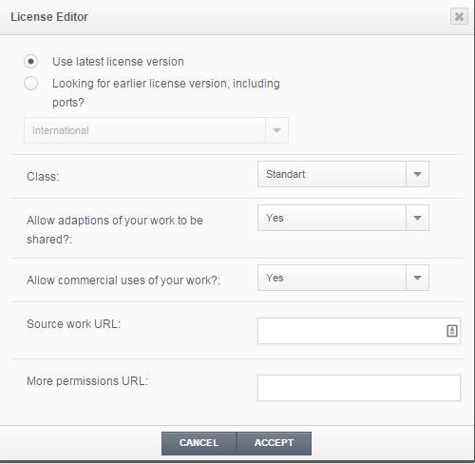

Figure : Open license editor

Here are the main licensing options:

* Class
  + **Standard** – Nominal restrictions placed on the work (see following bullet points)
  + **CC0**: “No rights reserved” – places the item in the public domain
  + **Public domain mark** - same as CC0 but a slightly different graphic is associated with this class
* Allow adaptations of your work to be shared?
  + **Yes**: Anybody can take your work, adapt it, and share it in any way without requiring your permission.
  + **Yes, as long as other share alike**: Any new product created that includes your work must be shared with the same Creative Commons license as your original work.
  + **No**: Nobody is allowed to make and share any adaptations of your work.
* Allow commercial uses of your work?
  + **Yes**: Others may take your work and incorporate it into products the sell; they do not owe you anything.
  + **No**: Others may not use your work in any product that is sold.

Below the CC license section is a text box where you can add notes, as appropriate. Ignore the section on templates because it is not relevant for uploaded files and then click *Submit*. The file is now in the system and when you build your course, you will be able to select and add it. For complete details of how Creative Commons licensing works, see the Creative Commons website: <https://creativecommons.org/licenses/>.

At this point, your file is not yet published. This means that it is not “discoverable” and you will not be able to find it when you want to add it to a course or collection. Normally you would leave an item unpublished if you expect to make modifications or have a colleague review it. However, remember to make it “published” before trying to load it into a course.

### Add a Lecture

*Lectures* are usually video recordings of live campus lectures. As such, you will need to know a video’s URL (if hosted on a generic server) or its *embed code* (if hosted on YouTube) in order to add it to ***OEWeb***. The process for adding a lecture is very similar to the process for uploading a file.

Click *OCW* on the dashboard, click the plus sign, and choose *Lecture* for the type. The general data are the same as for a file, but on the second page you must upply a URL or YouTube embed code (on the YouTube video page, click *Share* followed by *Embed*, and copy the code provided.) Paste the URL or code into the appropriate textbox and click *Next* (Figure 18).

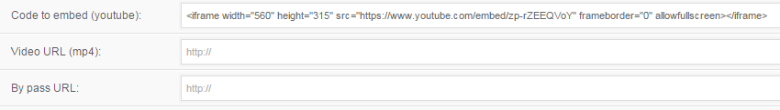

Figure : Data entry form for YouTube embed code

The next window asks for author, university, and licensing information (just like for uploading a file). Enter the required information and click *Next*. (Don’t forget to click the green plus sign to add the author’s name to the course.) You can also add an image, which will appear on the course lecture page.

The next window allows you to choose a layout for the lecture’s web page. Click on the desired layout and then click *Submit* (Figure 19).

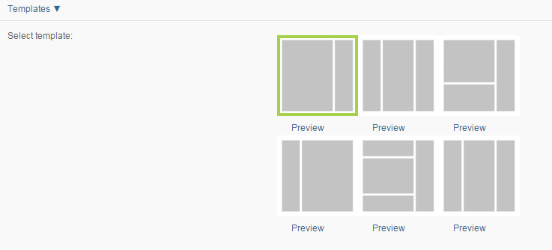

Figure : Web page layout template

Now you have a file and a lecture for your course. The final step is to create the course’s “shell” and link the content items to it.

### Create a Course Shell

From the dashboard, click on *OCW* and then the plus sign. For type, choose *Course*. The title of the example course is *History of Ancient Music*. The general data form appears in Figure 20 and the next page of the course form appears in Figure 21. The URLs can be left blank unless there are course contents hosted outside of ***OEWeb***. *Credit Type* allows you to choose whether the course counts toward a degree, Continuing Education Units (CEUs), or continuing professional education, and *Credits* allows you to specify the number of units.

You can add book data (for a textbook associated with the course) by clicking on the *Book* *Data* arrow, which causes the form to expand downward (Figure 22). The information to be supplied on this page is self-explanatory; note that the book author does not need to be in the database since he/she may not necessarily be affiliated with your institution. The image uploaded here appears on the course home page in a shaded area for book information.

The next two pages of the form are the now-familiar *Author & University* form and the *Template* form. The image uploaded to the *Author & University* form will appear on the course’s home page.

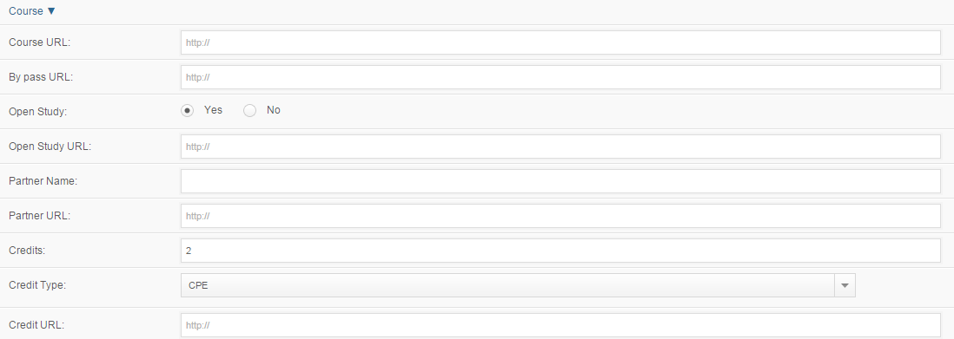

Figure 1: Course-specific data

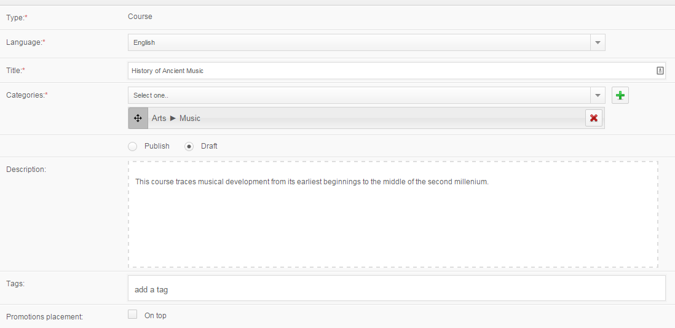

Figure 20: General course data

Click *Accept* and the course shell is saved. Keep in mind that the course and its contents have not yet been published. In order to connect the course shell with its contents, you need to publish those contents before moving to the next step.

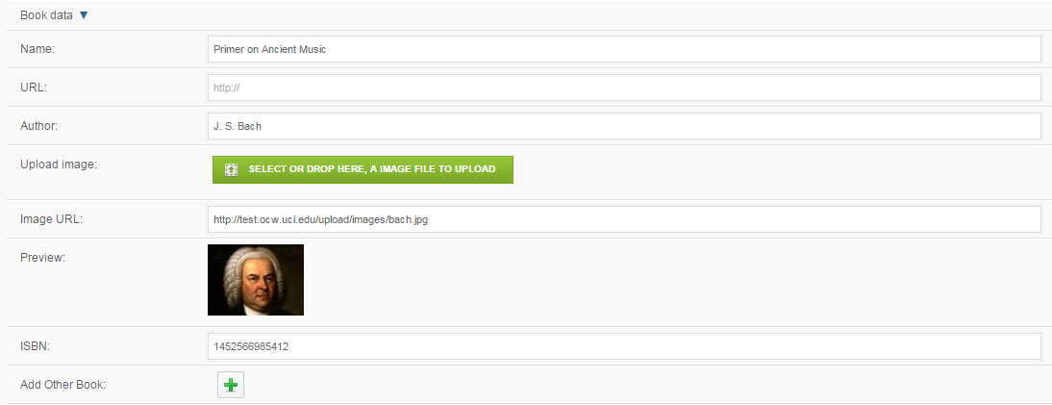

Figure 22: Book Data

From the dashboard, click on *OCW* and search for the two content items you just created. Click the checkboxes in the “Published” column. Now you are ready to put the pieces together!

## Step 5: Connect or “Join” the Content Items to the Course

Now that the components have been set up (file, lecture, course shell), you are ready to assemble them into a course. Begin by clicking on *OCW* from the dashboard and finding your course shell (Figure 23). Click the *Join* button and the window in Figure 24 appears.

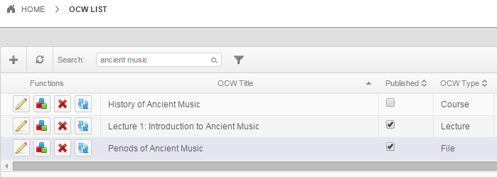

Join button

Figure : OCW list showing elements of the example course

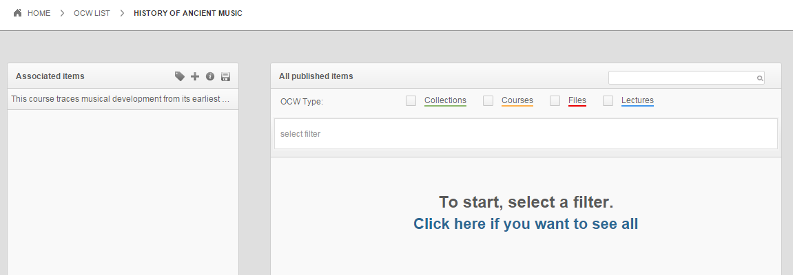

Figure : The "joins" window

The area on the left shows lectures and files (“learning objects”) that have been “joined” to the course shell and the area on the right is where you will find additional learning objects to join. Right now the area on the left is empty because nothing has been added, yet. As you can see, you can choose the types of objects you wish to view and further refine your search by clicking on “select filter” and specifying the author of the objects in which you are interested (Figure 25).

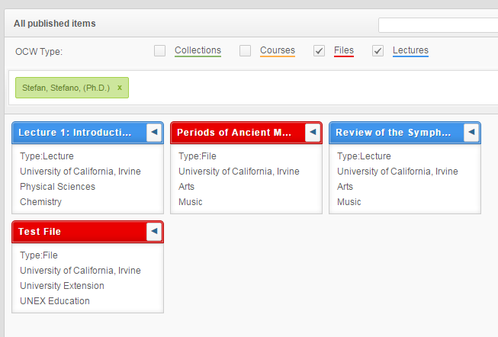

Figure : Learning objects available for joining

Select the items you want and click the leftward-facing arrow to move them into the *associated items* course layout workspace (Figure 26). These items are now “joined” to the course.

*Tip: If the title of the learning object is truncated, you can move your mouse over the window header and the full title will appear.*

***OEWeb*** allows you to organize your content’s appearance to facilitate navigation for users. You can add labels and headers by clicking on the appropriate icons shown in Figure 24. Each button opens a text box into which you can enter the appropriate text. Note that you can use your mouse to drag and reposition the objects as well as the headers and labels. Always remember to click the “save” icon to save the joins. Finally, Figure 27 shows how the layout appears to users on the front-end. Headers appear along the left part of the course page as well as in the central content area, and labels appear only within the content area.

Save joins

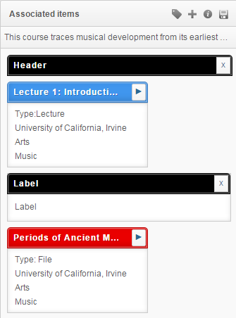

Figure : Layout window

Add a header

Add a label

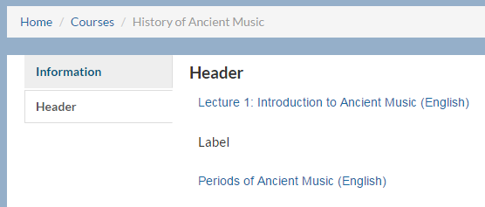

Figure : Headers and labels in the front-end

The course information page as users would see it is shown in Figure 28 (with a photo of an ancient instrument uploaded to the “author and university” section of the course data entry form and an image of Bach uploaded to the “author and university” section of the “books” portion of the data entry form).

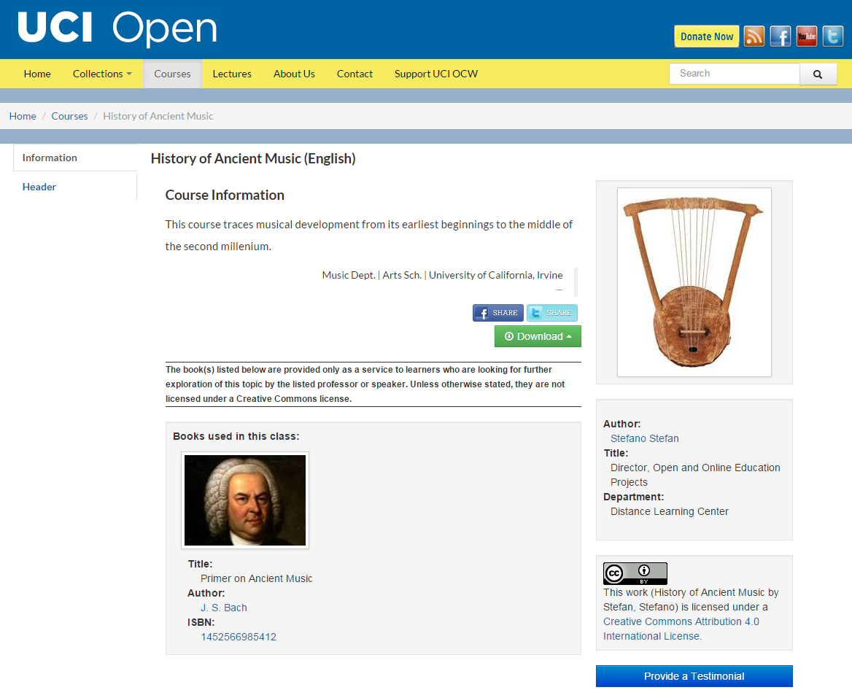

Figure : The course "home page"

# ADDITIONAL FUNCTIONALITY: TESTIMONIALS, CONTACT REQUESTS, BROKEN LINKS, AND PROMOTIONS

## Testimonials

Each page in ***OEWeb*** has a *testimonials* button, which users can click to enter comments into a form. Those comments are accumulated in a table and a user with administrative rights can review and “publish” those comments. For example, go to the CHEM 1P, Lecture 6 page (Figure 29). Click on the button “Provide a Testimonial” and enter your comments in the form that appears (Figure 30).

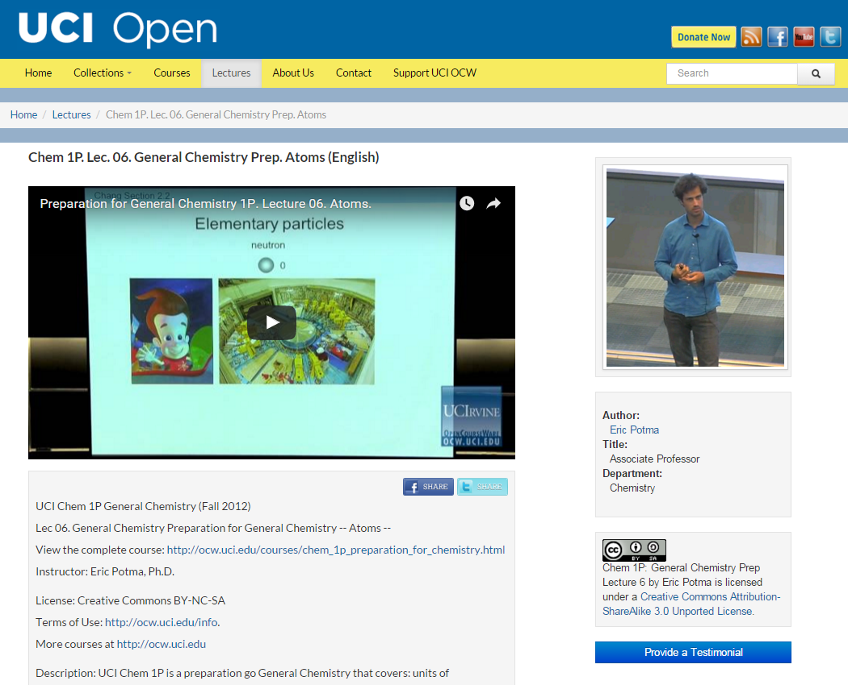

Figure : Web page for CHEM 1P, Lecture 6

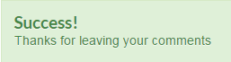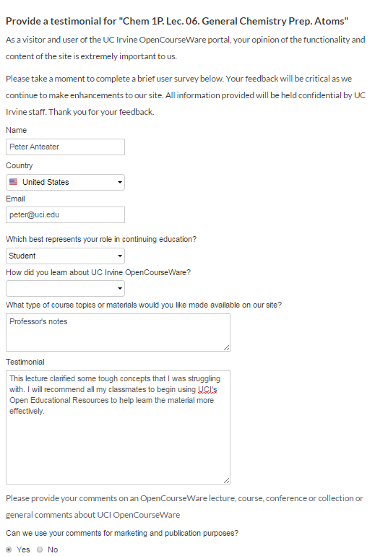

Figure : Testimonial form

Back to the administration site… Click on *Testimonials* and a table showing all recently submitted testimonials appears (Figure 29). You can see the CHEM 1P testimonial at the top. Click the magnifying glass icon to read the testimonial. To make it visible on the website, click the “visible” checkbox and then go to “OCW” on the dashboard. Find Lecture 6 and click on the “refresh cache” button (Figure 32) and then the testimonial will appear on the lecture’s web page, at the bottom (Figure 33).

View testimonial

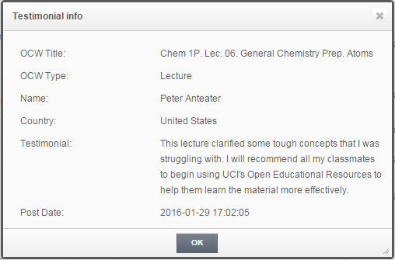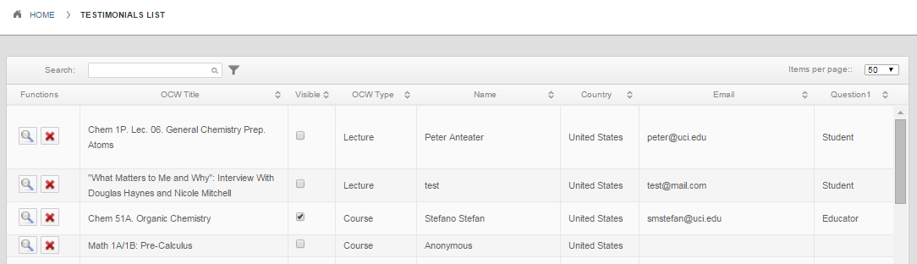

Figure : List of recently submitted testimonials

Refresh cache



Figure : CHEM 1P lecture entry

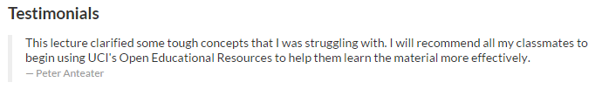

Figure : Testimonial appearing on the lecture web page

Note that the testimonial will appear on the page from which it was originally submitted.

## Contact Requests

Users can submit a request to be contacted by clicking on the *Contact* menu from the ***OEWeb*** home page, which then displays a form (Figure 34).

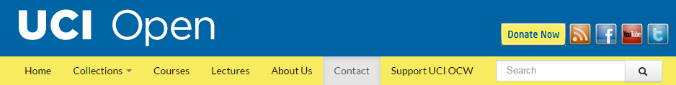

Click to request contact

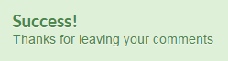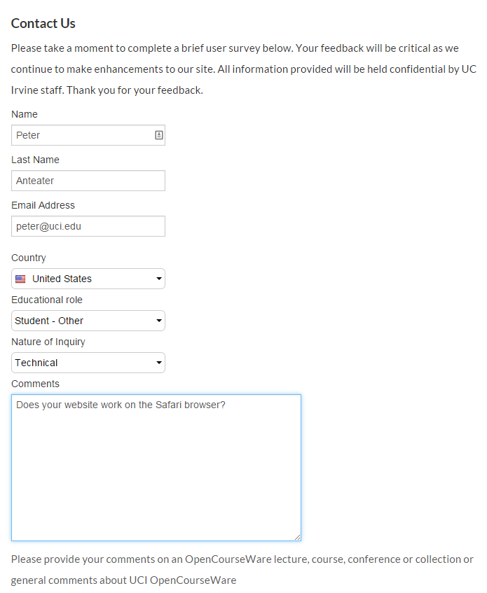

Figure : Contact request form

Submitting this form updates ***OEWeb***’s *Contacts* database and administrative users can view the requests by clicking on the magnifying glass icon (Figures 35 and 36).

Click

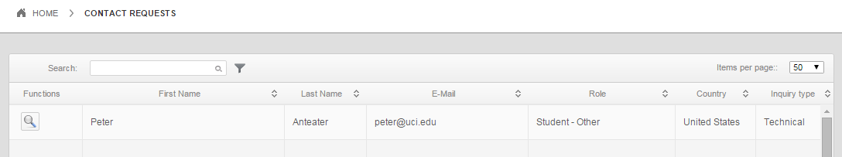

Figure : Contact request list

View

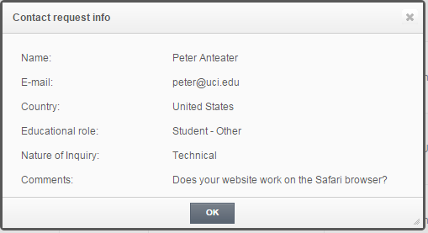

Figure : Contact request details

A staff member can then send a response to the email address provided.

## Broken Links

From the dashboard, click on “Broken Links.” This displays a list of web addresses that ***OEWeb*** checked (automatically) and found to produce HTML error 404 results. You can check each link and effect repairs, if necessary.

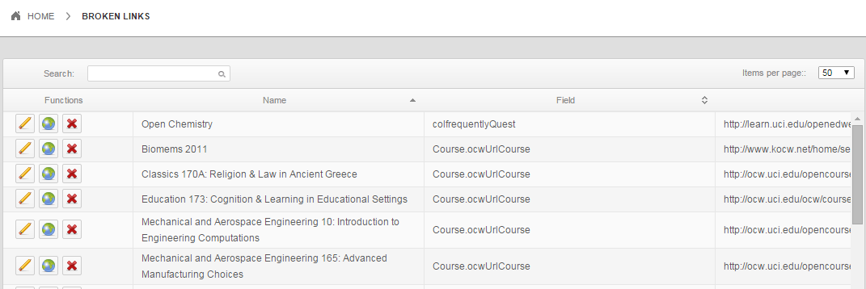

Figure : Broken links list

The functions icons (Figure 38) allow you to edit the page having the problem, see the page through your browser, or delete the entry (for links that were temporarily non-functioning but are now functioning).



Figure : Broken links functions

## Promotions

The *Promotion* function allows you to place rotating graphic items on any page in the site. “Rotating” means that you can designate several images to appear on a particular page and have them appear randomly each time the page loads. For example, suppose you want to showcase three students who have benefitted from a particular course. You can designate photos of all three to appear on that course’s page so that each time someone views that page, a different student’s photo appears.

You can also specify a time frame during which the image will appear. For example, if you are promoting a webinar using this feature, specifying the time frame will ensure that the image is no longer visible after the webinar concludes.

### Setting up a promotion

From the dashboard, click on *Promotions* and the window in Figure 39 appears. Click on the plus sign to add a new promotion (Figure 40).

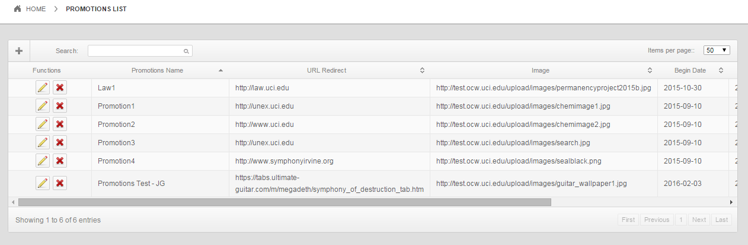

New promotion

Figure : Promotions

Enter the requested information including the type (*donation* or *sponsorship)* and specify where you want the promotion to appear, namely in connection with a collection, a course, or a specific lecture. Next, select the category (or categories), and choose particular pages on which the promotion should appear. (Selecting a category first narrows down the range of possible pages on which the promotion will appear. In this example I have specified *course* for the type and *music* for the category so that I can choose only music courses for placement of the promotion). Note that you can place the same promotion on multiple pages. promotion). Note that you can that you can place the same promotion on multiple pages. Next, upload an image for the promotion itself and specify the date range during which you wish the promotion to be visible.

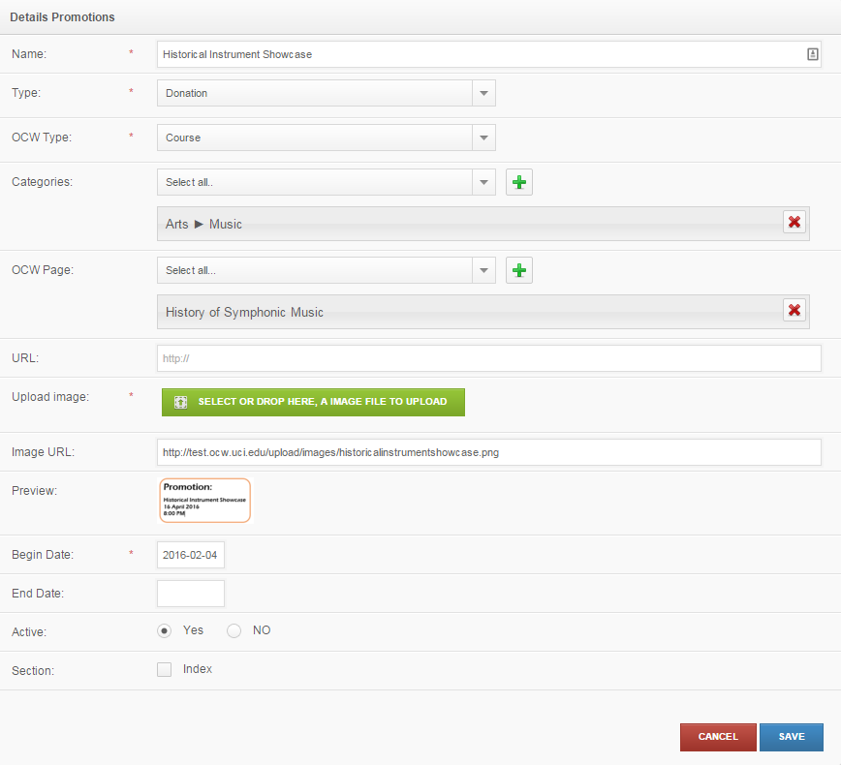

Figure : Promotions page

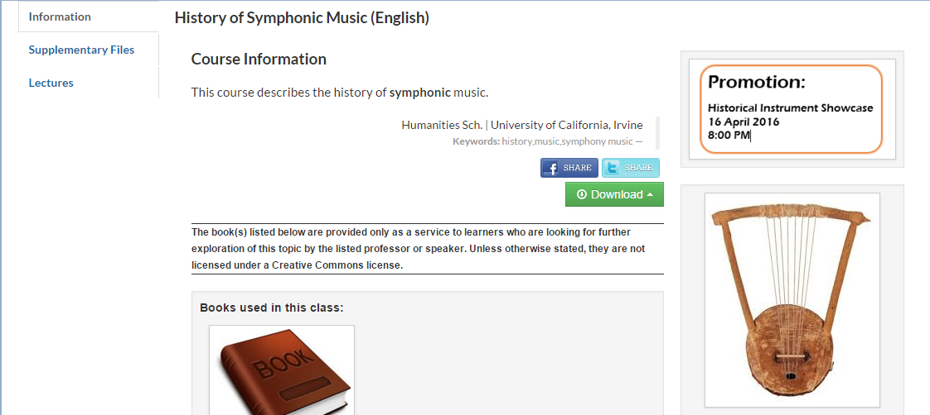

Promotion image

Figure : Promotion appearing on course page

Note that you must clean the ***OEWeb*** website cache in order to see any changes that you make. (From the dashboard, click on *OCW* and then click the *clean* button.)

Clean the cache

Figure : Clean the cache

### Setting up rotating promotions

To illustrate the ability to have rotating promotions, create three promotions and have them rotate on the *History of Symphonic Music* course page. In addition to the music history webinar, add Historical Instrument Showcase and Music History Symposium. Use images that are truly promotional, as follows:

  

Music History Webinar Historical Instrument Showcase Music History Symposium

The promotions page now includes all three promotions (Figure 43), which all point to the *History of Symphonic Music* course page. View the course page and you see the first of the three images (Figure 44). Reload the page, and the second image appears (Figure 45). Reload the page once more and the third image appears (Figure 46).

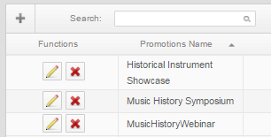

Figure : Promotions

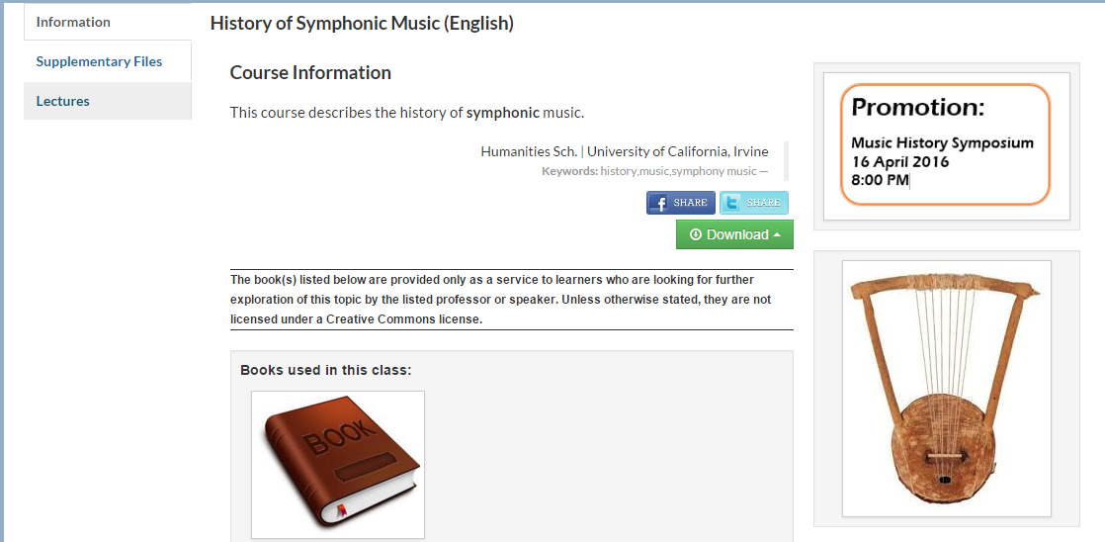

Figure : Course page showing symposium promotion

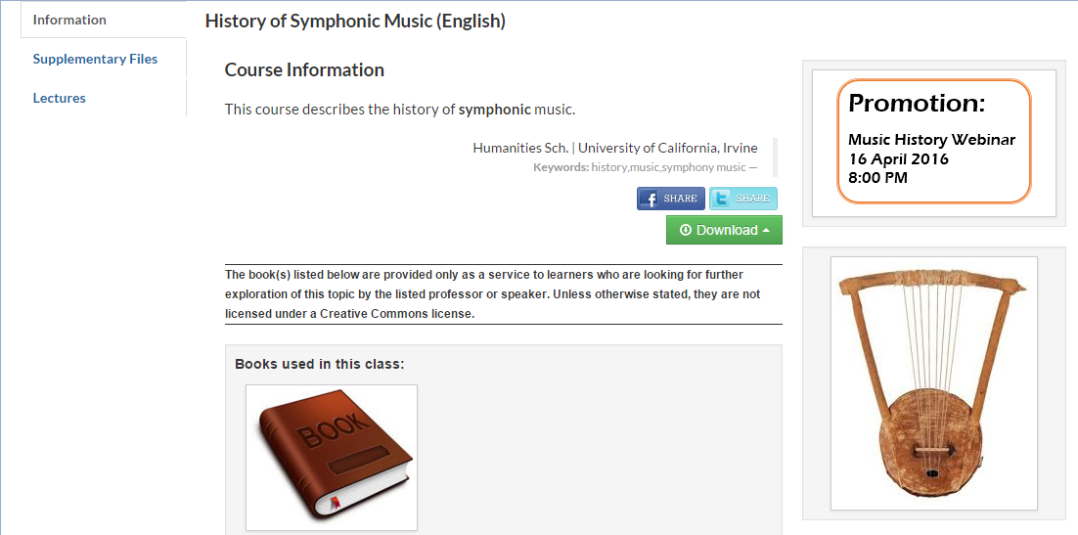

Figure : Course page showing webinar promotion

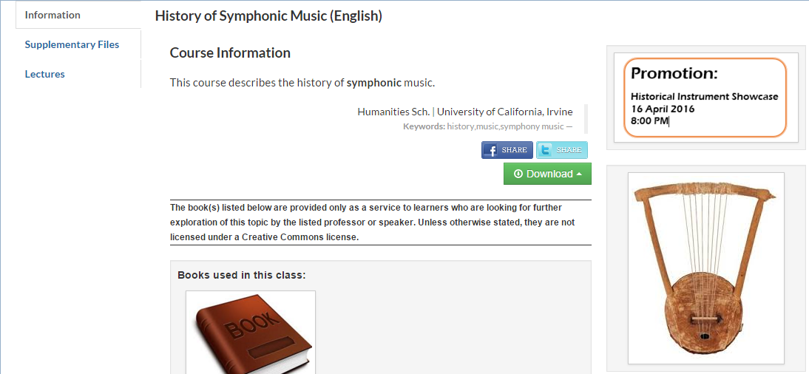

Figure : Course page showing instrument showcase promotion

## Arbitrary Content

***OEWeb*** allows users to customize the layout and content of each page. The first of two methods of doing this allows users to place arbitrary content on a page. Suppose you want to add an image of the composer J.S. Bach to the course page of *History of Symphonic Music* in the left-hand column.

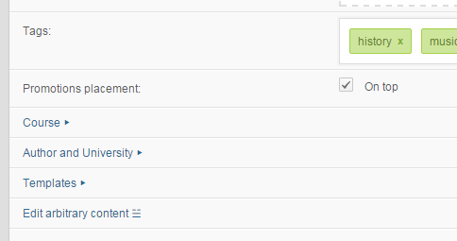

Figure : Location of "edit arbitrary content"

From the dashboard, click on *OCW* and edit the course. Click on *Edit arbitrary content*, which appears toward the bottom of the course form (Figure 47). This opens a graphic layout of the page with places in which you can add content marked as shown (Figure 48).

Click on the *add element* box where you want the image to appear. In this example, choose the box in the left-hand column. From the pop-up window (Figure 49), specify the type of content you wish to upload. There are three options:

* Text
* Image (static)
* Video

For this example, choose the static image. Drag-and-drop the image of Bach from your desktop to the green area or, alternatively, enter the URL for the image if you do not have it locally.

Click to add arbitrary content

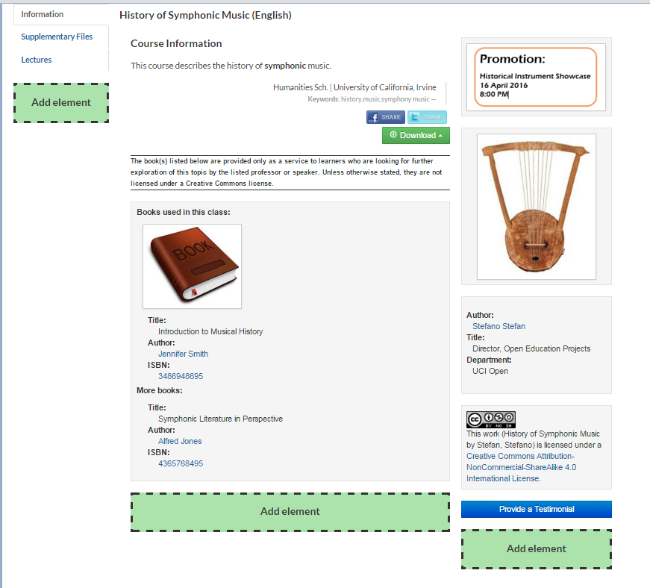

Figure : Page editor showing locations where arbitrary content can be added

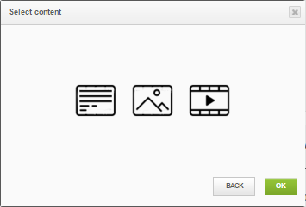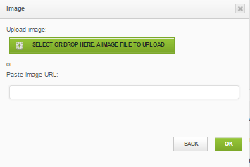

Figure : Content type selection pop-up window

Figure : Drag-and-drop file upload feature

The image then appears on the course layout page (Figure 51) and if it looks acceptable, click on *Save* at the upper right. Note that you can add more arbitrary content, if desired.

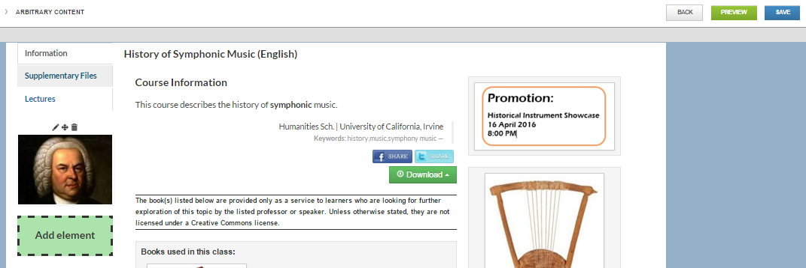

Figure : Page layout with arbitrary content added

The final page is shown in Figure 52.

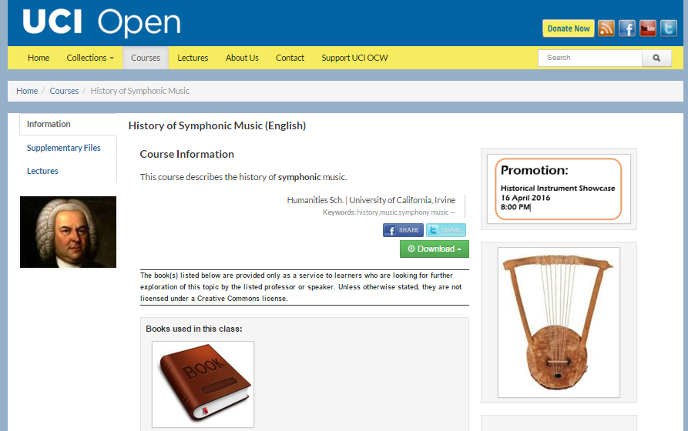

Figure : Completed page with arbitrary content and promotion in place

For videos, the pop-up that appears after you click “add element” asks for a YouTube video link plus an optional starting point (Figure 53); for text, a text box appears in the page into which you can write your text (Figure 54).

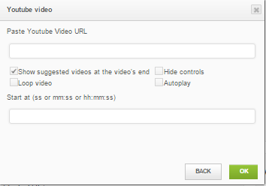

Figure : Video selection window

Text editing functionality

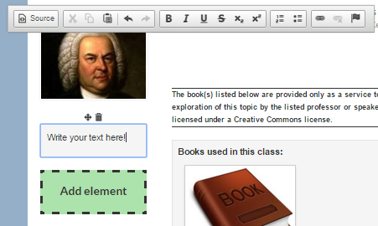

Figure : Text entry point for arbitrary content

## Layout Templates

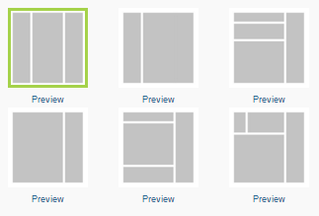

Figure : Six page templates

The second way to customize the appearance of a page is by choosing one of six templates (Figure 55). For a given page, the active template is surrounded by a green border. To experiment with the templates, click on OCW from the dashboard and edit the page you wish to modify. Click on *Templates* (near the bottom) and choose a template. If you click *Preview*, you’ll see a small image depicting how a course page might appear with that template (Figure 56). Click on *Apply* to make that template active.

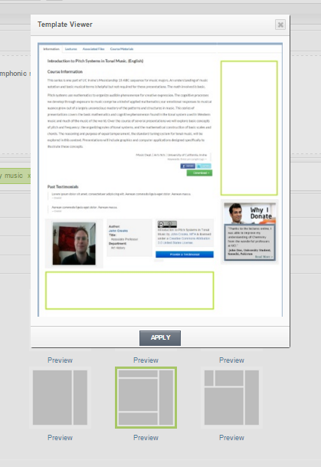

Figure : Template viewer

As an experiment, apply this template to *History of Symphonic Music*. The results appear in Figure 55. This serves as a good lesson: be careful which template you pick – just because a layout exists does not mean that it is an appropriate (or aesthetically pleasing) option. Fortunately, ***OEWeb*** allows you to choose and test other templates quite easily.

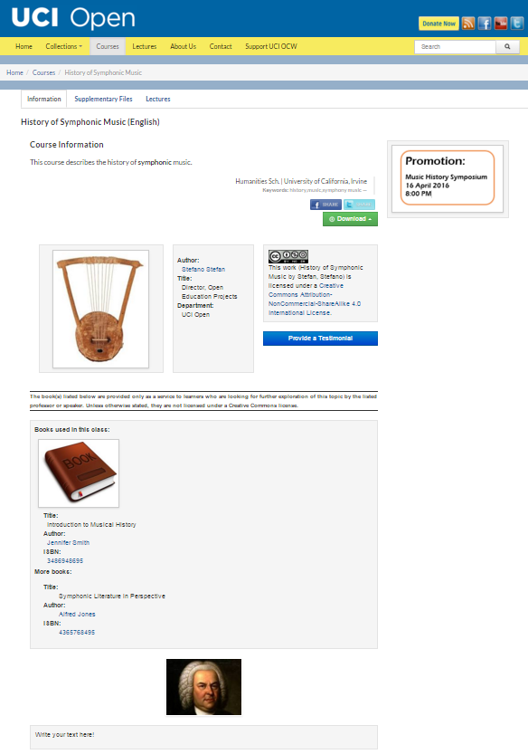

Figure : History of Symphonic Music with a new layout

# FUNCTIONAL REFERENCE

## Dashboard Functions

### OCW

* Purpose: Create (add), view, modify, or delete all site contents
* Functions:
  + **Add (plus sign).** Generates a new, blank data form.
  + **Search.** Allows users to find specific content items.
  + **Filter.** Allows users to reload or clean content items based on search results **.**
  + **Edit**. Displays a content item’s information in a web form with the following parameters:
    - Type (Collection, course, file, or lecture)
    - Language: The language in which the content item was developed
    - Title: Title of the content item (arbitrary)
    - Categories: (Subjects and/or topics of the content item)
    - Publish/Draft radio buttons: *Publish* indicates that the item is visible to anyone and that the item can be added to a course or collection via the join operation; *draft* indicates that the item is visible only to its creator.
  + **Join.** Displays a web form for a container shell into which subordinate items can be moved. For example, a *course* can contain lectures, files, and descriptive text.
  + **Delete.** Allows users to delete the corresponding content item.
  + **Clean Cache.** Allows users to “flush the cache” thereby making website changes visible.
* Parameters:
  + **Published.** When checked, the corresponding content element is visible to website visitors and to the *Join* operation.
  + **OCW Type.**  Course, collection, file, or lecture
  + **University/School/Department.** Institutional administrative divisions
  + **Thumbnail.** Thumbnail of graphic item used to identify the course
  + **Has note.** TBD

### Categories

* Purpose: Create, edit, or delete academic subject areas (topics), which are called *categories*.
* Functions:
  + **Add category:** Allows users to create a new category .
  + **Save changes:** Allows users to save modifications made to the category list.
  + **Edit (category):** Allows users to modify an existing category name.
  + **Delete (category):** Allows users to delete an existing category.
  + **Drag-and-Move:** Allows users to move categories around the window including up/down to re-order them or left/right to make categories become sub-categories of other categories. *Categories* appear within dropdown menus in several places throughout the website and assume the same structure in those menus as they have on the *Categories* page.

### Persons

* Purpose: Add records for people associated with open education content hosted on the website.
* Function:

**Add.** Displays a blank web form into which users can enter personnel information for instructors, faculty members, and others who are authors or collaborators of courses hosted on the site.

* Data:
  + First Name (required)
  + Last Name (required)
  + Degree (search academic degrees already entered into the system; click on green plus sign to select)
  + Email and optional email addresses
  + Personal URL (website)
  + Phone number
  + Address (mailing) – can specify two addresses
  + City, state, country, and zip code (for U.S. addresses)
  + Departments – Search academic institution information already entered into the system using the *Universities* dashboard operation
    - Opens a pop-up form with the following fields (all are required):
      * University
      * School
      * Department
      * Title (e.g. professor, lecturer, etc.)
    - Click on the green plus sign to select; note that a person can be associated with several universities, schools, or departments, and can have different titles in connection with different institutions.
  + Sponsor – checking this checkbox opens input controls for the following items, which pertain to the sponsoring entity:
    - Is organization (checked or unchecked)
    - Name (required – name of sponsoring organization)
    - URL
    - Image URL
    - Email
    - Phone
    - Address

### Degrees

* Purpose: Create, edit, or delete degree names.
* Functions:
  + **Add.** Allows users to add a new degree and specify the degree abbreviation (e.g. B.S.) and a short description (e.g. Bachelor of Science). Both are required elements.
  + **Edit.** Allows the modification of existing degree abbreviations and short descriptions.
  + **Delete.** Allows the deletion of existing degrees.

### Universities

* Purpose: Create, edit, or delete institutions.
* Functions:
  + **Add.** Allows users to add a new institution (i.e. university) name. (Please use this category even if your institution is not called a university.)
  + **Edit.** Allows users to add and edit institutional details including the name of the institution, schools, and departments via a window labeled *University Details.*
    - University name (edit) – modify the institution’s name
    - *Schools* actions:
      * **Edit.** Allows users to edit school names.
      * **Delete.** Allows users to delete an existing school.
      * **New department.** Allows users to add a department to a particular school.
    - *Departments* actions:
      * **Edit.** Allows users to edit department names.
      * **Delete.** Allows users to delete an existing department.

### Testimonials

* Purpose: Collect and display user-generated testimonials; allow users to make testimonials visible.
* Functions:
  + **View.** Allows users to view submitted testimonials and related details. Details include:
    - Title of the content item to which the testimony is tied
    - Type (course, lecture, collection, etc.)
    - Name of person submitting the testimonial
    - Country of origin
    - Testimonial text (what the user submitted)
    - Post date: Timestamp created when the testimonial was submitted
  + **Delete.** Allows users to delete a submitted testimonial.

### Contact Requests

* Purpose: Display short messages submitted by website visitors.
* Function: **View.** Allows administrators to view submitted information
* Data captured by the contact request web form include:
  + Name
  + Email address
  + Country
  + Educational role (i.e. student, instructor, etc.)
  + Nature of Inquiry – Can select from the following options:
    - Technical
    - Course content
    - Intellectual property
    - Feedback
    - Accessibility
    - Other

### Promotions

* Purpose: Create, edit, and delete promotions.
* Functions:
  + **Add Promotions.** Create a new promotion.
  + **Edit.** Modify promotion details.
  + **Delete.** Delete an existing promotion.
* Promotion data:
  + Name
  + Type (Donation or sponsorship)
  + Content type on which the promotion will appear (collection, course, or lecture)
  + Categories associated with the promotion (based on content type)
  + Specific page on which the promotion is to appear

## Website Header Functions

At the top of the Dashboard page are three functions:

**Modules:** Provides a shortcut to the dashboard modules (OCW, Categories, Persons, etc.).

**Settings:** Allows adding administrative users to the system, modifying administrative user roles and privileges, viewing and deleting cached pages, and viewing/modifying pages with broken links (this is the same function as the one appearing on the dashboard).

**Logout:** Terminates the current session and logs the user out.

Here is a more detailed explanation of the *Settings* function:

### Users

Click on *Settings* followed by *Users*. The window in Figure 58 appears.

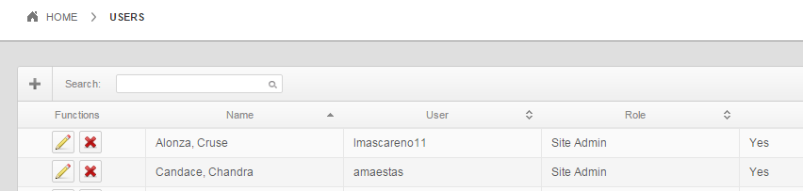

John Smith

Jane Doe

Figure : User account list

Click the plus sign to add a new administrative user or click the edit button to edit a user’s information (Figure 59).

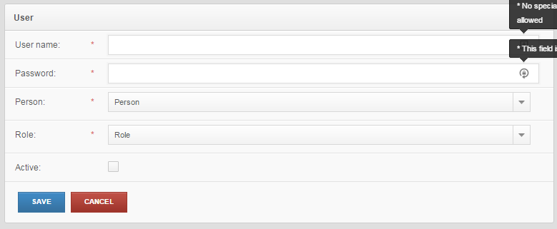

Figure : Administrative user information

The dropdown menu *Person* lists all the people who have been entered into the *Persons* data table so you need to ensure that administrative users to be added have been entered into the system before attempting to give them administrative rights (Figure 60).

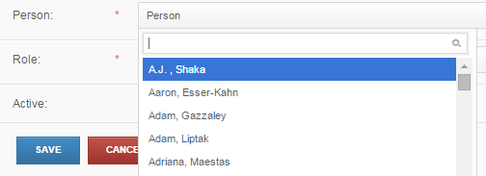

Figure : Person drop-down menu

The *roles* are those that have been defined in advance (see below).

### Roles

Select *Roles* from the *Settings* dropdown menu. The window shown in Figure 61 opens. The table shows existing roles along with all the permissions that have been granted to those roles. Clicking the *edit* or *delete* buttons allows administrators to modify role permissions (Figure 62) or delete roles altogether. As shown in the figure, administrators can scroll down a list of permissions and check those to be granted.

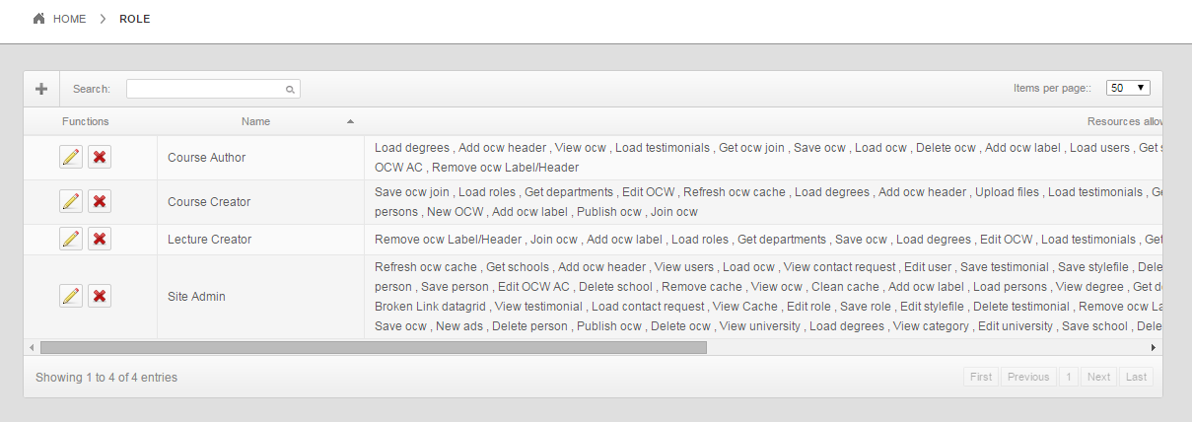

Figure : List of roles and permissions

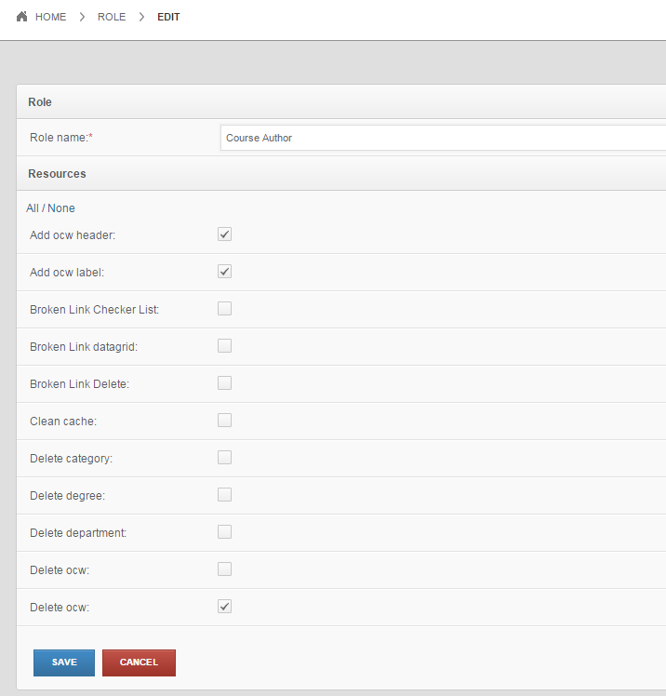

Figure : Permissions associated with the Course Author role

### Cache

Click on *Cache* and a table of cached web pages appears (Figure 63).

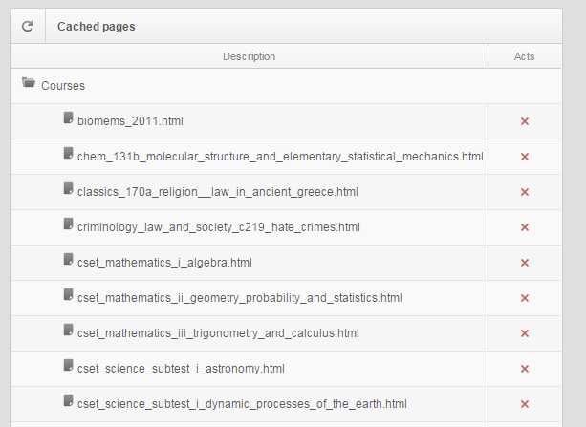

Figure : List of cached web pages

You can delete individual cached pages here or delete all cached pages with one click from the OCW List page (Figure 64).

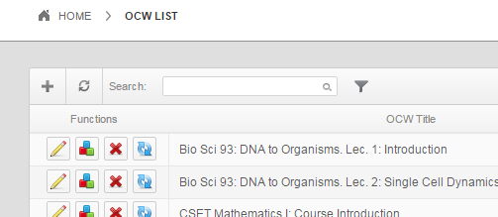

Click to clean the cache

Figure : Complete cache cleaning